**Solution Sheet For Group Exercise 1**

***I have tried my best to formulate this solution sheet error free, but if still any error is present then kindly let me know.***

**Q 13)** **Using KVL calculate I and V in the circuit of Fig. 1.**

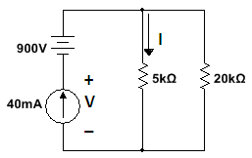

**Sol 13)** The source current of 40mA flows through the parallel circuit of 5k and 20k. Therefore we can use current division rule to estimate the current through 5k resistance. By current division rule:



To calculate the voltage drop across the current source of 40mA, we apply KVL in the first loop containing 5k resistor, 40mA current source and 900V voltage source.



***# To be noted: In this circuit the voltage-source voltage has effect on the voltage across current source, but it has no effect on the current through 5k resistor.***

**Q14) Calculate V1 and V2 in the circuit shown below**

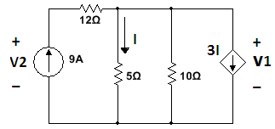

***Hint : use both KVL and KCL to solve the circuit***

**Sol 14)** First we calculate the current ***I*** in terms of dependent voltage source ***V1***. From the circuit we can observe that:



Therefore, the depended source has voltage



Applying KCL on the top right hand node gives



From the above equation we get



Voltage drop across  resistor is



Now applying KVl around the outside loop, we get:



***#To note:  resistor has no effect on V1 , but it has an effect on V2***

**Q15)** **Find the values of *I1* and *I2*.**

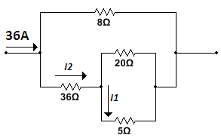

**Sol 15)** We can use current division rule two times to find the value of I1.

Before applying current division rule in the circuit provided, we can find the total resistance of the lower branch of resistances (i.e.)



Now by applying current division rule in the two branches of resistors we get:

 And 

**Q 16)** **Find the value of voltage *V1* and current *I1 in the circuit given below*.**

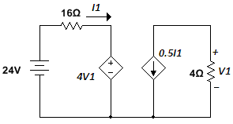

**Sol 16)** If we enclose the two halves of the circuit by two different surfaces then we can see that the two currents flowing in the surfaces are coming out from the common wire. Since by KCL algebraic sum of current entering a node is zero, we can say that there is no current flowing in the lower wire which is common to both halves of the circuit.

Now, by applying KVL in the left half of the circuit we get:



Whereas, in the right half of the circuit we can apply Ohm’s law:



From equation (1) and (2)



From equation (2) and (3), we get:



**Q17) Find the values of mesh currents *I1* and *I2*.**

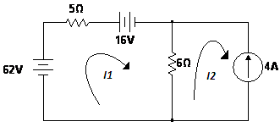

**Sol 17)** Looking into the loop 1, we can observe that the current I1 is entering from negative terminal of 62V and positive terminal of 16V respectively. Assuming current entering from positive polarity of the battery is positive and negative polarity is negative, one can write the equation for voltage drop around mesh 1 as:



**[*# Since 6Ω is common to both I1 and I2, and currents I2 and I2 are flowing in opposite direction in 6Ω, we have considered 6(I1-I2) in the Mesh 1*]**

From mesh 2, we can see that I2 is flowing opposite to that of the current through current source, therefore:



From equation (1) and (2), we get



**Q 18) Find the values of *I1*, *I2* and voltage *Vx*.**

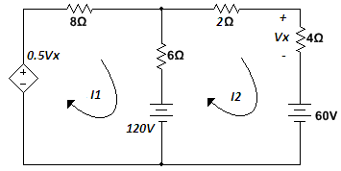

**Sol 18)** Hint: ***It is always better to find the value of voltage of dependent voltage source:***

From the loop 2, we can see that I2 is entering positive node of resister 4 Ohms.

Considering the current entering from the positive polarity of any node is positive and negative polarity is negative, we get:

From loop 2:



From loop 1:



Applying KVL in the mesh 1:



By applying KVL in mesh 2:



Simplifying equation (3) and (4) give us:



**Q 20)** **Find the Thevenin’s equivalent circuit at terminals *a* and *b* of the circuit shown below.**

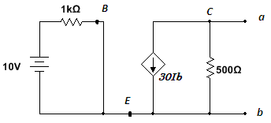

Ib

**Sol 7)** # ***Circuit shown above can help you in your future classes related to transistor modeling.***

From the left half of the circuit we can find the value of Ib:



***# Finding Thevenin’s voltage across a load is equivalent to finding open circuit voltage across two ends of the load.***

Thevenin’s voltage (Vab) is the voltage across 500Ω resistor, therefore



To find the Thevenin’s resistance, we can deactivate the independent Voltage sources (in this case 10 V source). After deactivating the voltage source current Ib = 0, therefore, dependent current source 30Ib will be also 0 (i.e. the dependent current source acts as open circuit). In this case the Thevenin’s resistance is the resistance 500Ω itself. Resulting Thevenin’s equivalent circuit can be drawn as shown below:

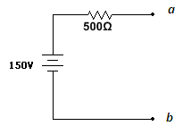

**Q 21) What is the Norton’s equivalent circuit of the circuit shown below?**

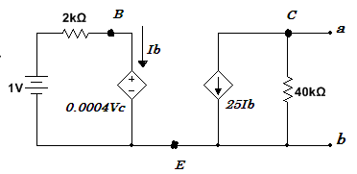

+

Vc

-

**Sol 21)**

***# Finding Norton’s current (Isc) through any load is equivalent to finding short circuit current through the load.***

In this case it is better to find short circuit Norton’s current (Isc) then open circuit Thevenin’s voltage (VTh) and correspondingly RN = RTh = VTh / Isc

To find the short circuit current Isc, we have to short circuit the terminals a and b. Resultant circuit is shown below:

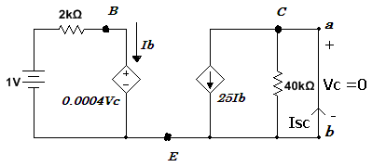

Short circuiting a and b results in Vc = 0.

In the left half of the circuit, the dependent voltage source is short circuited because Vc = 0. Now Ib can be calculated as:



In the right half of the circuit the current Isc can be given by:



***# Note current Isc is entering from node b.***

To find the Thevenin’s Voltage (VTh) across 40KΩ resistor, we can open circuit the load end. The open circuit voltage Vc is given by:



By applying KVL in the left half of the circuit we get:



Or



From (3) and (4)



***# Negative VC represents that terminal b is more positive than terminal a, therefore the actual polarity of VC is opposite to that provided in the question.***

Now after knowing Voc and Isc, we can calculate the RN or RTh by:



Norton’s equivalent circuit is shown below:

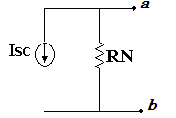

50kΩ

12.5mA